С Л А В А
The National School Slavic Honor Society
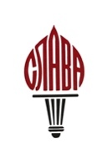

Chapter:_________________________
Initiation held on*:_______________________
School:__________________________
Signature of Advisor_____________________
Full Name  List in alphabetical order as names are to appear on the certificate and National records | Membership Classification  student/faculty/honorary

REMEMBER:
- Please include initiation fee ($10 per member).
- Check must be payable to American Councils.
- ADVISOR must sign this form.
- Please send the check and the form to: Olga Gotta, 14A Powder Horn Hill Rd, Wilton, CT 06897
* If a certificate needs to be dated as of a particular date, please include initiation date. Otherwise, it will show the date, when the certificate was issued.

